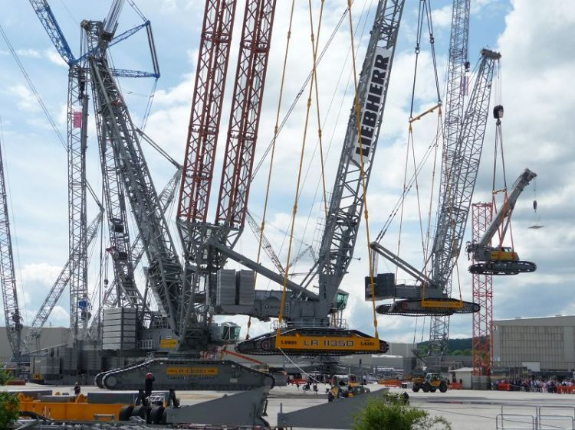

Construction systems (structural components)

By

Linchong Pan

100571672

Apply Structural Principles to Residential Low-rise Constructions

CPCCBC4010B

Submission date

Sunday, 7 October 2018

The date field is called a dater and is also active, just click and a date picker control box will appear

# Contents

Contents ii

Table of Figures ii

Introduction 3

DETIALS 4

Conclusion 9

References 9

# Introduction

Provide details on the construction systems adopted for a low-rise residential construction project and how the construction will be coordinated and managed within the project as a whole:

* site evaluation
* excavation
* footings
* floor
* walls
* roof
* waterproofing – general & specific

# DETIALS

Site evaluation

The main goal of site evaluation is ensuring the building site is a suitable location the project, which include site investigation and site grading analysis. During the investigation, there 4 steps need to be done:

* Ensure the site is complete safe for construction
* Groundwater quality
* The site values compare to regulatory management values like drinking water.
* Prepare the management strategy.

Excavation

The entire excavation includes:

* setting out corner benchmarks
* surveying ground and top levels
* excavation to the approved depth
* dressing the loose soil
* making up to cut off level
* the construction of dewatering wells and interconnecting trenches
* making boundaries of the building
* the construction of protection bunds and drains (WOLLAM, 2015)

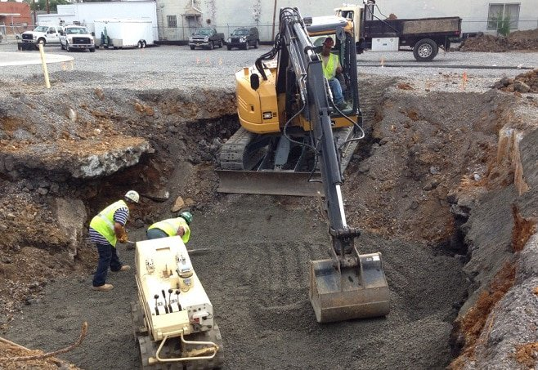

footings

The commonly used footing types include:

* bored pier footings
* column or stump
* pier and beam
* concrete slab.

For low-rise residential project, concrete slabs are widely used for better cost efficiency.

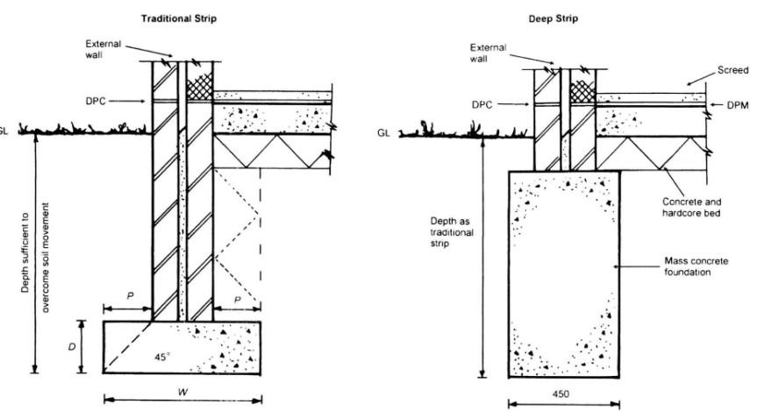

floor

After the floor joists have been loaded on the bearers, the floor is placed over the underlayment. The following image indicates the structures:

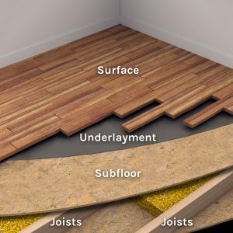

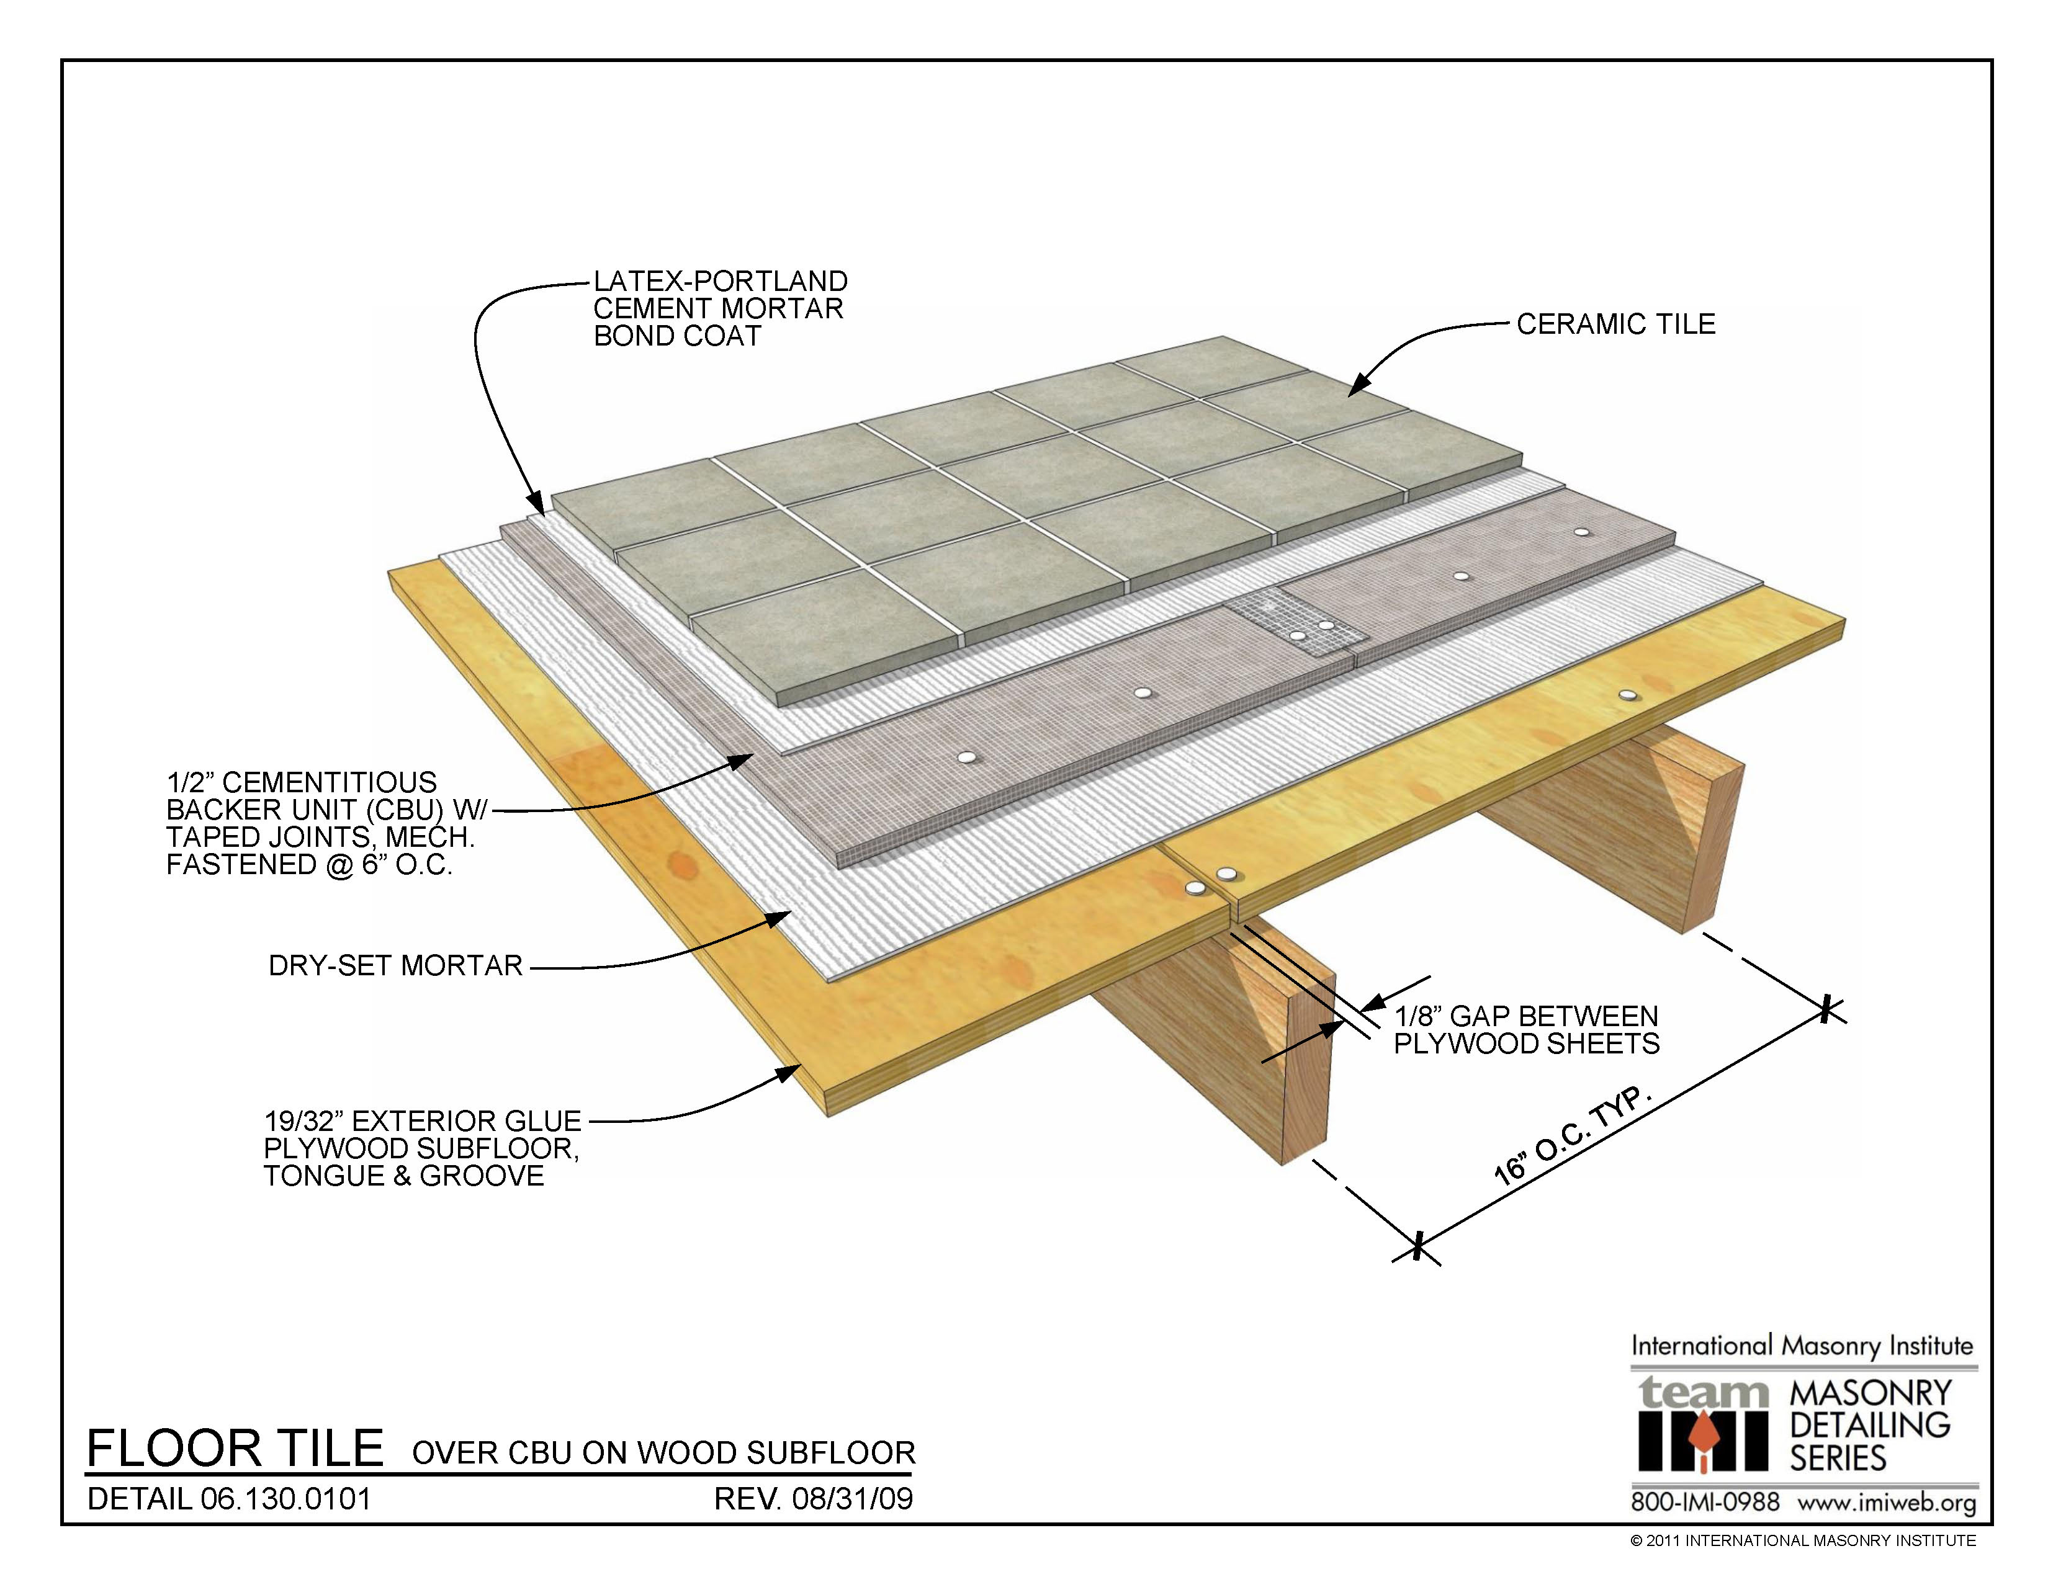

The more detailed floor may include dry-set mortar, backer Unit and bond coat.

walls

The external wall and internal wall often use different materials

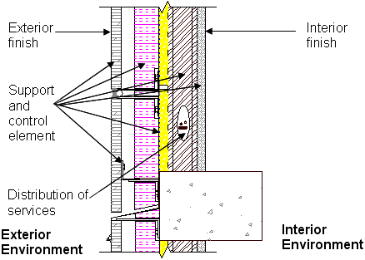

In general, wall system contains support and control element, distribution of services, interior finish as well as the exterior finish.

roof

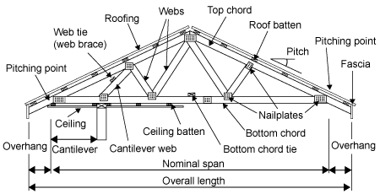

Roof can be finished by using pitched and propped construction, however, unlike the floor and wall system, roof often need to be done after the previous steps and ceiling system. Working at height is also a challenging task.

waterproofing – general & specific

AS 3740 Waterproofing of wet areas in residential buildings establishes the performance requirement for wet areas in Classes 1 and 10 buildings as set out in Table 3.8.1.2 of the NCC, Volume Two.

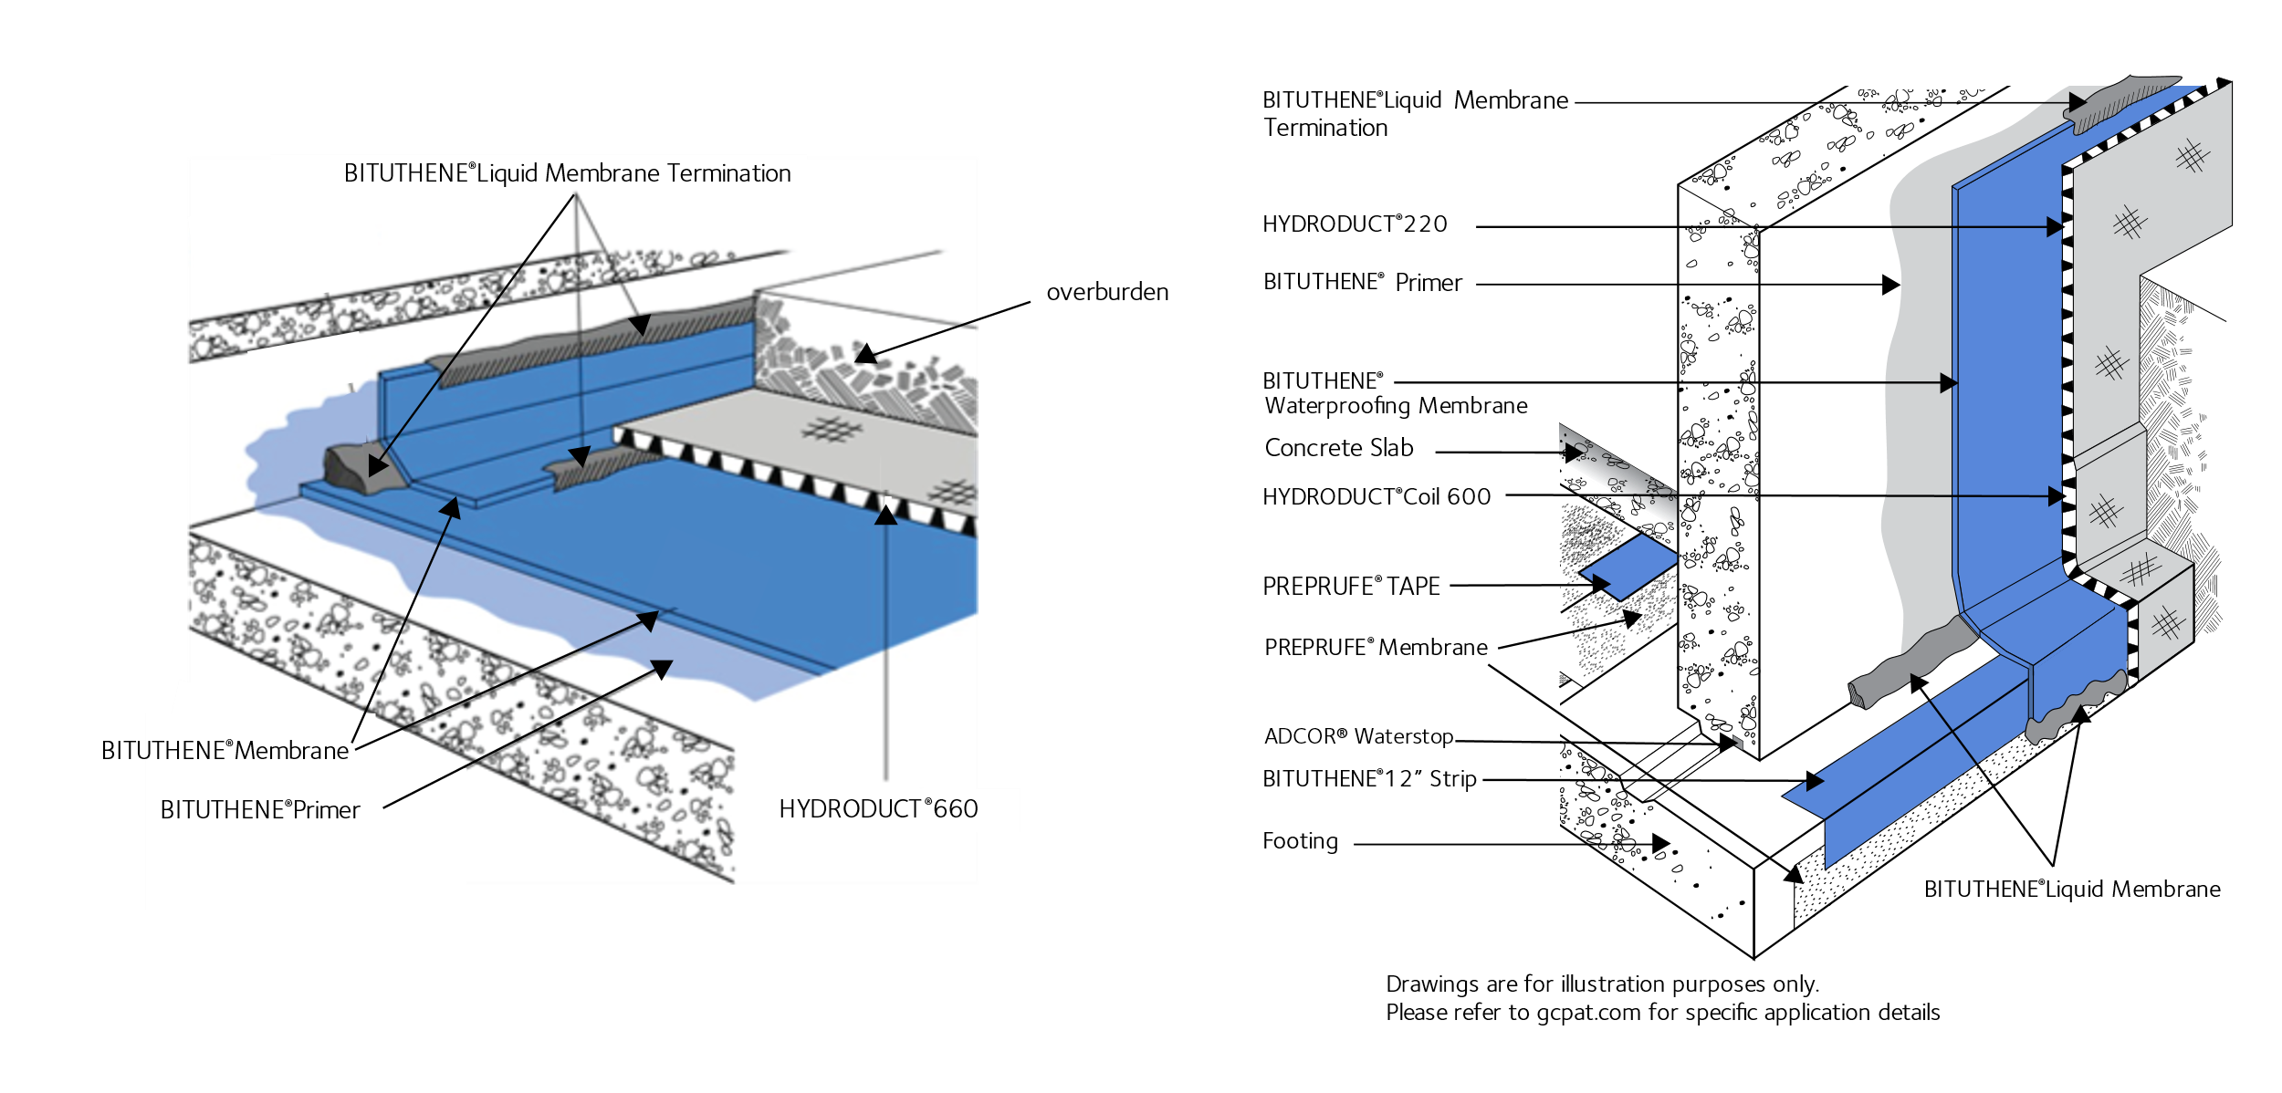

A common product should have several standards, for example, Membrane for application to surfaces at ambient temperatures of 40 °F (5°C) or above, or when surface and ambient temperatures are at 40 °F (5°C) or above

# Conclusion

It is important to provide details site evaluation, excavation, footings, floor, walls, roof, waterproofing – general & specific during the product when preparing the Structural Principles.

# References

Australia Standards, 1992. *AS2124 General Conditions of Contract,* Sydney: SAI global.

Australia Standards, 2002. *AS4915 Project Management,* Sydney: SAI global.

Australian Standards, 2002. *AS 1170 0.1 Structural Design Actions Part one: Permanent, Imposed and Other Actions,* Sydney: SAI global..

SAI global, 2004. *HB 240-2004 Guidelines for managing risk in outsourcing,* Canberra: s.n.

SAI global, 2004. *HB 436: 2004 Risk management guidelines companion to AS 4360: 2004,* Canberra: s.n.

WOLLAM, M., 2015. *EXCAVATION CONSTRUCTION.* [Online]   
Available at: https://wollamconstruction.com/excavation-construction/